Given the root of a binary tree, return *the* ***maximum width*** *of the given tree*.

The **maximum width** of a tree is the maximum **width** among all levels.

The **width** of one level is defined as the length between the end-nodes (the leftmost and rightmost non-null nodes), where the null nodes between the end-nodes that would be present in a complete binary tree extending down to that level are also counted into the length calculation.

It is **guaranteed** that the answer will in the range of a **32-bit** signed integer.

**Example 1:**

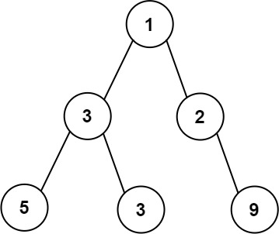

Input: root = [1,3,2,5,3,null,9]  
Output: 4  
Explanation: The maximum width exists in the third level with length 4 (5,3,null,9).

**Example 2:**

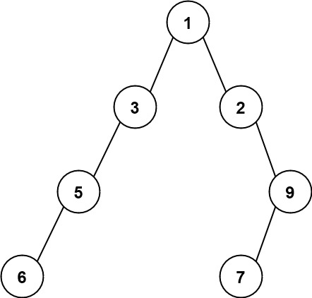

Input: root = [1,3,2,5,null,null,9,6,null,7]  
Output: 7  
Explanation: The maximum width exists in the fourth level with length 7 (6,null,null,null,null,null,7).

**Example 3:**

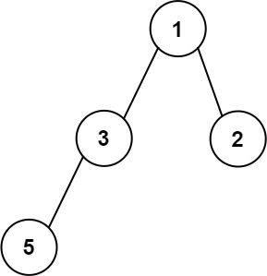

Input: root = [1,3,2,5]  
Output: 2  
Explanation: The maximum width exists in the second level with length 2 (3,2).

**Constraints:**

* The number of nodes in the tree is in the range [1, 3000].
* -100 <= Node.val <= 100